**New engine version of the Radius Capture plugin**

***The current engine version of the Radius engine plugin exists and is working. Note that the strategy for porting this plugin over from the console was to first bring over all of the functionality to create a working engine version. This was desired so that everything would stay consistent and working properly. Once ported over with identical functionality to the console version, it would then be possible to pare anything down as desired without compromising the baseline functionality.***

***This has been done with a few current exceptions. For example, the import and export functionality for options is currently not implemented. Is this desired?***

***The only added feature is a new check box that allows selecting, or de-selecting, the creation of a separate disk folder for each case being captured. Note that this feature is unchecked by default, meaning that all cases will be captured to the same disk folder.***

***The current layout of the dialogs are shown below.***

**The options dialog as it appears by default, with no options yet specified:**

New checkbox to specify separate folders for cases – unchecked by default (all cases saved to same folder)

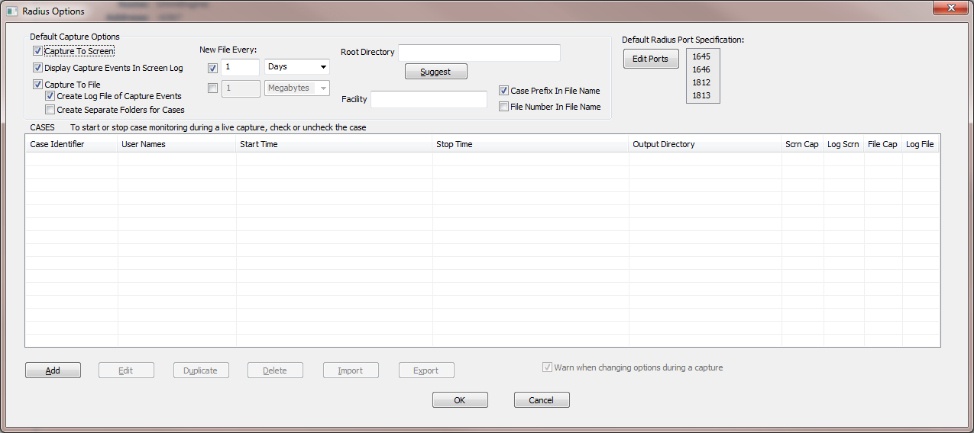

**With one case configured:**

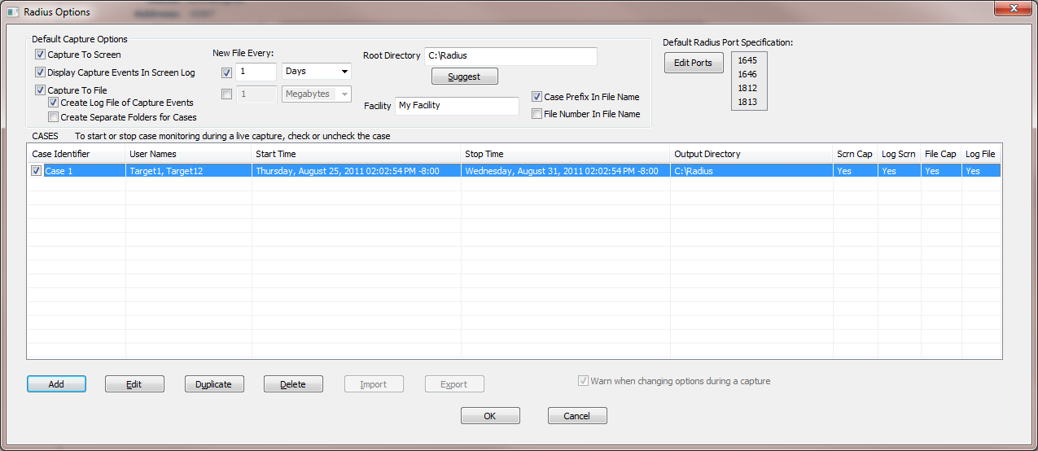

Currently disabled. Are these wanted?

All the case dialog boxes are currently the same as for the console version of the plugin. They are shown below as they would appear with the one case configured in the main options dialog above:

